**Homework #11 Part 1**

**Team 2:**

**Julian Carvajal Rico**

**Roberto Enriquez Vargas**

Table 1 shows the total execution times for Fortran and Numpy to locate a value of interest from a large sorted and unsorted array. The Fortran execution uses a linear search for the unsorted array and a binary search for the sorted array to find the value of interest. On the other hand, the Numpy execution uses a searchsorted function for the sorted array and a where function with the unsorted array to find the value of interest. The Fortran function is over 3 times as fast as its Numpy counterpart to find the same value in sorted array. However, the Fortran execution is only roughly 1.5 times faster its Numpy counterpart when searching through an unsorted array. In both cases, the results show it is significantly quicker to find a value of interest in a sorted array than an unsorted array. The output for the performance evaluation function can be seen in figure 1.

**Table 1. HW11 Results**

|  |  |  |
| --- | --- | --- |
| Method | Fortran Execution Time (s) | Numpy Execution Time (S) |
| Sorted Array Search | 0.000013 | 0.000041 |
| Unsorted Array Search | 0.006003 | 0.009470 |

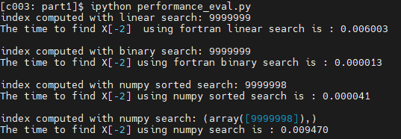

**Figure 1. Output Fortran and Numpy Searches**